The Neighbourhood Plan identifies the following nine buildings and structures that are considered to be of local significance for architectural, historical or social reasons. They are included in the Neighbourhood Plan as non-designated heritage assets and their locations are shown in Figure 12 of the Neighbourhood Plan (and replicated below).
1. The Old Rectory, Main Street - On site of 1416 rectory, renovated over the years and recently converted into two dwellings.
2. Saddington Reservoir - the reservoir was constructed 1797 as a feeder for the Grand Union Canal, the Tunnel was constructed 1793 – 1797, and is 883.6 yards (808m) long. The Reservoir Island includes timber hut and landing stage (early 20th century) with local history associations.
3. Queen’s Head public house, Main Street - Original building circa 1747, refurbishment circa 1847, renamed in honour of Queen Victoria.
4. The Grange, Smeeton Road - Previously Dalton House. An imposing building with unusual coach house with clock. Parts of the house date from late 18th century.
5. Reservoir View - Four late 18th century cottages with views to the reservoir.
6. Home Farm, Bakehouse Lane 1890 - With a teagle hoist at first floor level for hoisting grain etc.
7. Cottage Farm, Main Street - Includes structural elements dating from 17th, 18th and 19th centuries.
8. White Oaks, Smeeton Road - Previously the home of Peter Shilton between 1970 and 1975, goalkeeper for Leicester City Football Club between 1965 and 1975 and goalkeeper for England during the 1970s-90s.
9. Village well, Weir Road - Recently rediscovered at the village green, Weir Road. Shown as ‘pump’ on 1903 Ordnance Survey map.
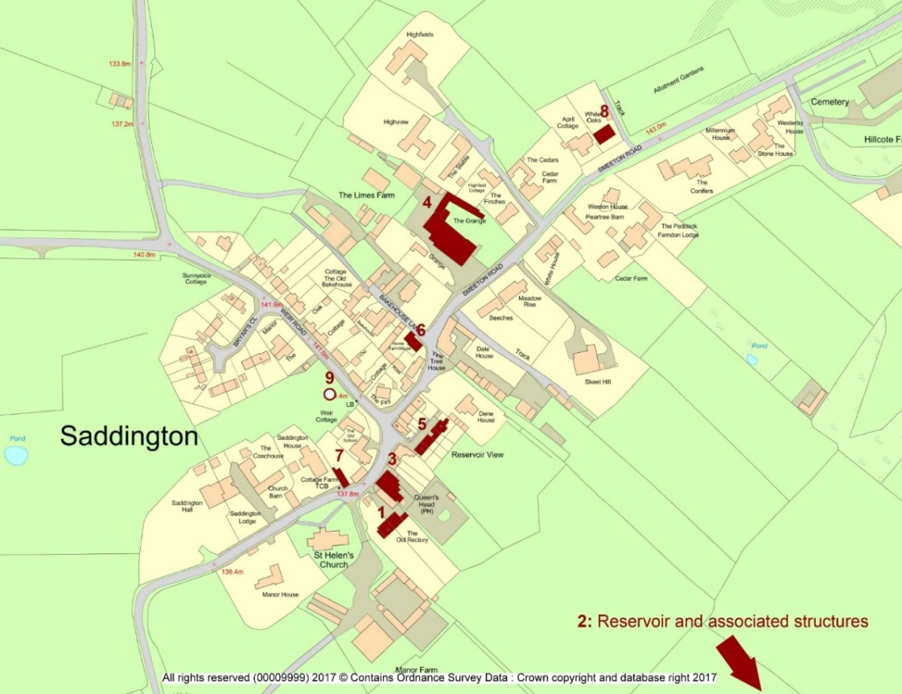
Additional information that supports the classification of these buildings and structures as non-designated heritage assets is provided in the following tables.
Building/Structure | (1) The Old Rectory, Main Street, Saddington
Age | The original rectory was built in 1416 to the east of the church.
Rarity  (as judged against local characteristics) | There are no other similar style dwellings in Saddington.
Aesthetic value/ Architectural Interest | A unique architectural style to part of front elevation with gothic style porches.
Group value  (visual / design/ historic) | Associated with St Helen’s church, originally as the rectory to the church.
Evidential value (significant contemporary or historic written record) | Raymond Grant’s book: ‘History of Saddington’ (1999)
Historic association  (Incl. important local figures) | N/A
Archaeological interest | Not considered to be relevant.
Designed landscapes | N/A
Landmark status (strong communal / historical associations / especially striking aesthetic value) | Not considered to be relevant.
Social and communal value (source of local identity, distinctiveness, social interaction and coherence) | Not considered to be relevant.
The Old Rectory  (Feb 2018) | 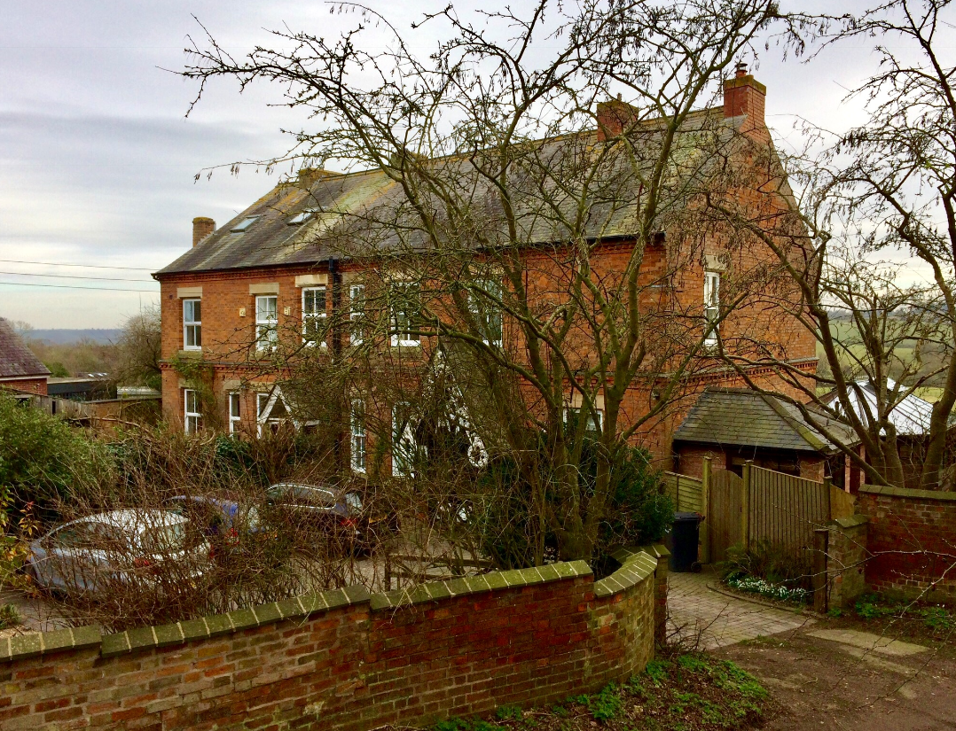

Building/Structure | (2a) Saddington Reservoir
Age | 1797
Rarity  (as judged against local characteristics) | The only local example.
Aesthetic value/ Architectural Interest | A beautiful area of open water surrounded by hedges and fields.
Group value  (visual / design/ historic) | Forms part of the canal system.
Evidential value (significant contemporary or historic written record) | Raymond Grant’s book: ‘History of Saddington’ (1999)
Historic association  (Incl. important local figures) | Not considered to be relevant.
Archaeological interest | Not considered to be relevant.
Designed landscapes | Not considered to be relevant.
Landmark status (strong communal / historical associations / especially striking aesthetic value) | Not considered to be relevant.
Social and communal value (source of local identity, distinctiveness, social interaction and coherence) | Saddington Sailing Club (RYA Affiliated)  Fishing Club  Walking
Saddington Reservoir | 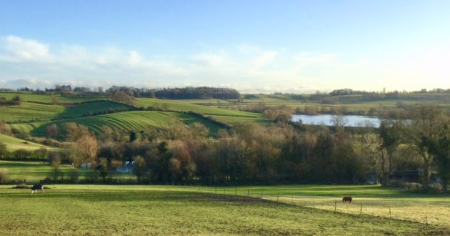

Building/Structure | (2b) Saddington Tunnel
Age | 1793 – February 1797
Rarity  (as judged against local characteristics) | The only local example of a canal tunnel and forming part of the Leicester section of the Grand Union Canal.
Aesthetic value/ Architectural Interest | The tunnel is 883.6 yards (808m) long.
Group value  (visual / design/ historic) | Forms part of the Grand Union canal system.
Evidential value (significant contemporary or historic written record) | Raymond Grant’s book: ‘History of Saddington’ (1999)  Forms part of the Saddington Reservoir feed arm canal system.
Historic association  (Incl. important local figures) | Not considered to be relevant.
Archaeological interest | Not considered to be relevant.
Designed landscapes | Not considered to be relevant.
Landmark status (strong communal / historical associations / especially striking aesthetic value) | Not considered to be relevant.
Social and communal value (source of local identity, distinctiveness, social interaction and coherence) | Forms parts of a well-used walking route along the towpath beside the Grand Union Canal. There is no footpath within the tunnel, the towpath continues above ground above the tunnel.
Saddington Tunnel | 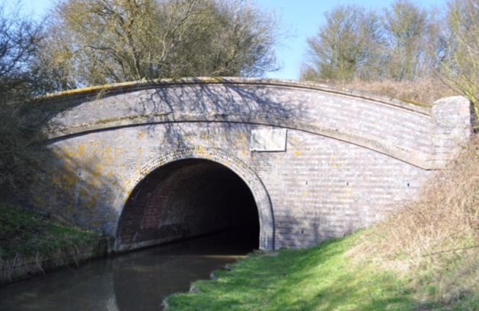

Building/Structure | (2c) Saddington Reservoir Island
Age | Circa 1916
Rarity  (as judged against local characteristics) | The only local example of such a structure, constructed from timber and corrugated iron. Hut and landing stage with steps.
Aesthetic value/ Architectural Interest | Not considered to be relevant.
Group value  (visual / design/ historic) | Not considered to be relevant.
Evidential value (significant contemporary or historic written record) | Raymond Grant’s book: ‘History of Saddington’ (1999)
Historic association  (Incl. important local figures) | Not considered to be relevant.
Archaeological interest | Not considered to be relevant.
Designed landscapes | Not considered to be relevant.
Landmark status (strong communal / historical associations / especially striking aesthetic value) | Not considered to be relevant.
Social and communal value (source of local identity, distinctiveness, social interaction and coherence) | A Saddington resident is a relative of the original creators of this social facility.
Saddington Reservoir Island | 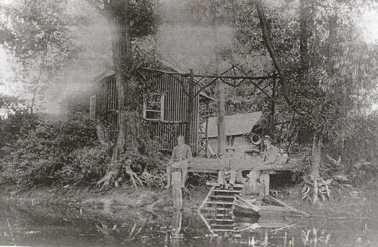

Building/Structure | (3) Queen’s Head public house, Main Street, Saddington
Age | Original building circa 1747, refurbishment circa 1847
Rarity  (as judged against local characteristics) | The Queens Head has been an “Ale House” for more than 150 years and is the only Public House In Saddington.
Aesthetic value/ Architectural Interest | Not considered to be relevant.
Group value  (visual / design/ historic) | The Public House sits within the village conservation area and due to its high location has outstanding views across the countryside and Saddington Reservoir. It has a garden at the back where the views can be appreciated and enjoyed by local residents and visitors from throughout Leicestershire.
Evidential value (significant contemporary or historic written record) | Raymond Grant’s book: ‘History of Saddington’ (1999)
Historic association  (Incl. important local figures) | An Inn has been on this site for at least 270 years and been an important part of the village during this time.
Archaeological interest | Not considered to be relevant.
Designed landscapes | Not considered to be relevant.
Landmark status (strong communal / historical associations / especially striking aesthetic value) | The public house sits within the heart of the village and is in close proximity to the church. It has been on this site since 1747 and has been known as the Queens Head well over 150 years.
Social and communal value (source of local identity, distinctiveness, social interaction and coherence) | The Queens Head is a popular public house which also serves as a restaurant. It is the only one located in Saddington and is therefore popular with locals and newcomers to the village. It on occasions holds meetings and also events during the year such as Barbeques and Bank holiday events such as having slides and a bouncy castle for children
The Queen’s Head  (Feb 2018) | 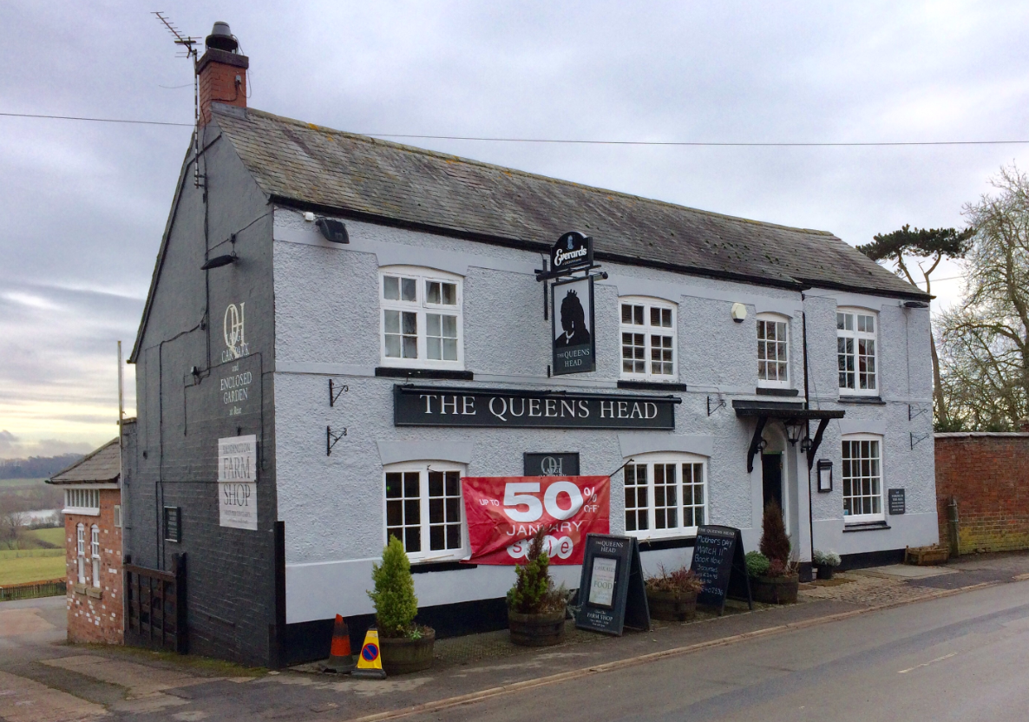

Building/Structure | (4) The Grange, Smeeton Road, Saddington
Age | Original date unknown, but parts of the house date from late 18th century.
Rarity  (as judged against local characteristics) | The only remaining example in Saddington of a large imposing country home of this size.  Previously known as ‘Dalton House’
Aesthetic value/ Architectural Interest | The building is surrounded by a sturdy red brick wall, and has an unusual coach house with clock. The kitchen contained an indoor well.  A very large redwood tree is planted in the front garden. This particular redwood is a ‘Wellingtonia’ and has a soft outer bark. Its full title is Sequoiadendron giganteum.
Group value  (visual / design/ historic) | Not associated with any other buildings in the village.
Evidential value (significant contemporary or historic written record) | Raymond Grant’s book: ‘History of Saddington’ (1999) - describes The Grange:  In 1938 for a short period it was owned by Otto Bowman who ran a private school called Mill Hill School. The Westerby Bassett hounds used to be kennelled here, looked after by the kennel-huntsman Mr Stanley Philips. During the second world war children were evacuated here. Since 1965 The Grange has been runs as a private nursing home.
Historic association  (Incl. important local figures) | See above.
Archaeological interest | Not considered to be relevant.
Designed landscapes | Not considered to be relevant.
Landmark status (strong communal / historical associations / especially striking aesthetic value) | The building is an imposing sight as you go along Smeeton Road, with the giant redwood tree creating a distinctive characteristic of Saddington village.
Social and communal value (source of local identity, distinctiveness, social interaction and coherence) | The Grange Nursing and Residential Care home provides a valuable service to the community, offering accommodation and 24 hour nursing care for up to 50 people with health conditions, and physical and sensory needs including dementia. Accommodation is arranged over two floors and there is a passenger lift to assist people to get to the upper floor.
The Grange  Nursing Home  and  Coach house with clock tower  (Feb 2018) | 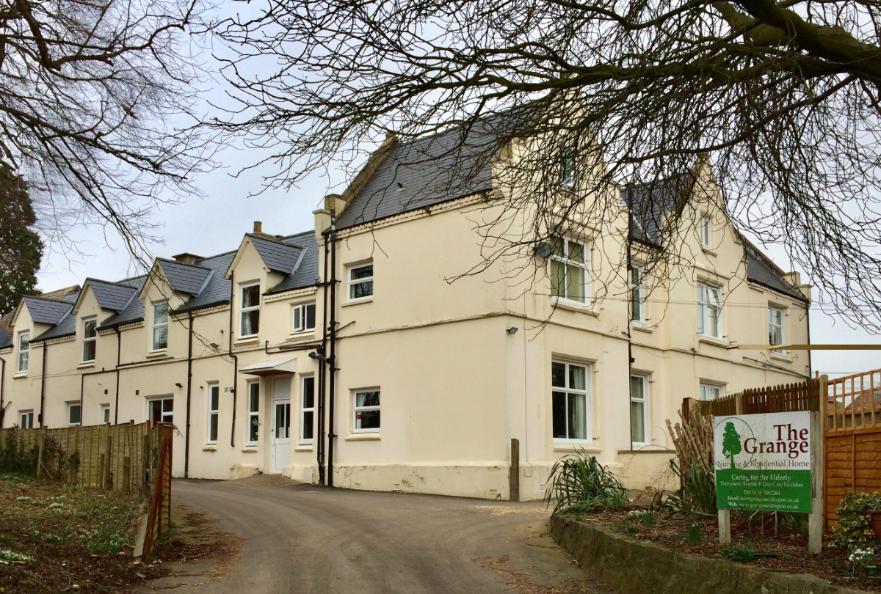 | 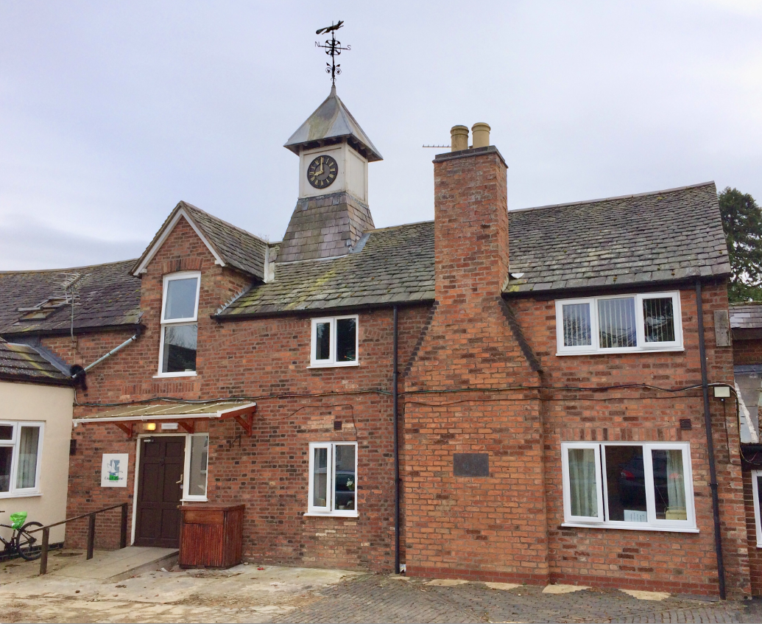

Building/Structure | (5) 1 - 4 Reservoir View, Saddington
Age | 1830
Rarity  (as judged against local characteristics) | No other similar row of farm cottages facing open fields in the areas.
Aesthetic value/ Architectural Interest | As above
Group value  (visual / design/ historic) | Terraced farm labourers’ cottages with simple extensions to the rear. Formerly known as ‘Bottom Row’ as there was a row of similar cottages behind Reservoir View between Reservoir View and Main Street.
Evidential value (significant contemporary or historic written record)
Historic association  (Incl. important local figures) | Home of the only medically qualified Alexander Techniques Teacher in the world 1992-1995.
Archaeological interest | Not considered to be relevant.
Designed landscapes | All gardens have a ha-ha onto the open fields.
Landmark status (strong communal / historical associations / especially striking aesthetic value) | See above.
Social and communal value (source of local identity, distinctiveness, social interaction and coherence) | Entirely distinctive. No other cottages in the area have the open aspect.
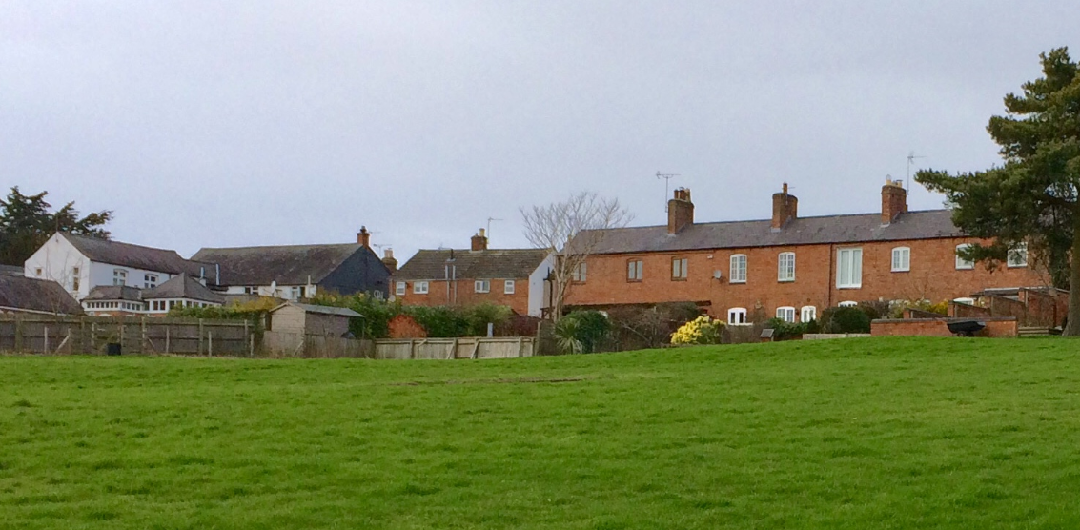
Reservoir View (Feb 2018)

Building/Structure | (6) Home Farm, Bakehouse Lane, Saddington
Age | Built in approximately 1840 and in 1890 became a bakehouse.
Rarity  (as judged against local characteristics) | An original baking oven remains inside Home farm and on the outside a Teagle grain hoist is situated which was used for lifting grain into the building.
Aesthetic value/ Architectural Interest | Not considered to be relevant.
Group value  (visual / design/ historic) | Saddington has many red brick houses within the village but home farm is distinct due to the grain hoist and outbuildings.
Evidential value (significant contemporary or historic written record) | Raymond Grant’s book: ‘History of Saddington’ (1999).  Ledger of sales for bread, flour and wheat to parishioners is currently held by the present owners.  British History online.
Historic association  (Incl. important local figures) | In 1890 baking was transferred from its original site to Home Farm where the original Goodwin & Barsby oven still remains although not in its original position.  The teagle hoist is in good condition and sits in a prominent position.
Archaeological interest | Not considered to be relevant.
Designed landscapes | Not considered to be relevant.
Landmark status (strong communal / historical associations / especially striking aesthetic value) | Home farm is positioned in the centre of the village within the conservation area and due to its location on a corner is very prominent. The teagle hoist can be seen if walking the Leicester round as the footpath runs immediately by the house.
Social and communal value (source of local identity, distinctiveness, social interaction and coherence) | As above. | 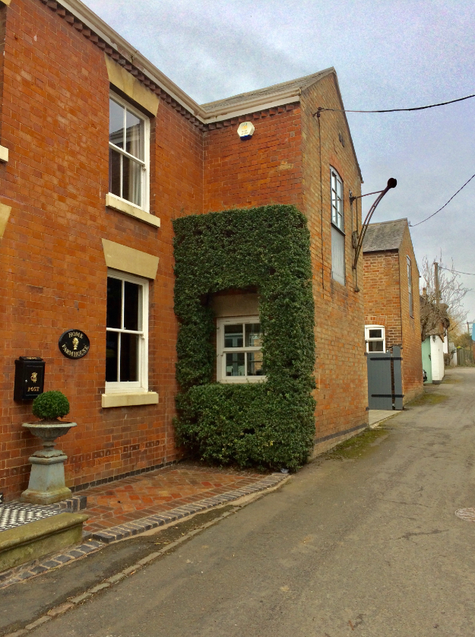
Home Farm
(Feb 2018)

Building/Structure | (7) Cottage Farm, Main Street, Saddington
Age | Exact age unknown but structural elements dating from 17th, 18th and 19th centuries.
Rarity  (as judged against local characteristics) | Cottage farm is made of red brick which is similar to other buildings within Saddington, but refurbishments to the property have uncovered structural elements dating back to the 17th, 18th and 19th century.
Aesthetic value/ Architectural Interest | As above.
Group value  (visual / design/ historic) | Is built with similar materials to other properties in the village, and is a fine example of a traditional English redbrick village dwelling.
Evidential value (significant contemporary or historic written record) | Raymond Grant’s book: ‘History of Saddington’ (1999).
Historic association  (Incl. important local figures) | During its history Cottage farm is thought to have served as a butchers shop.
Archaeological interest | Not considered to be relevant.
Designed landscapes | Not considered to be relevant.
Landmark status (strong communal / historical associations / especially striking aesthetic value) | Cottage farm has a large redbrick frontage, outbuildings and courtyard and is situated close to the road and within close proximity to the church. It lies within the conservation area in the centre of the village.
Social and communal value (source of local identity, distinctiveness, social interaction and coherence) | Due to its prominent position within the heart of the village and its similar identity to other houses Cottage Farm is integral to its surroundings. It has value and interest because of its age, history and condition.
Cottage Farm  (Feb 2018) | 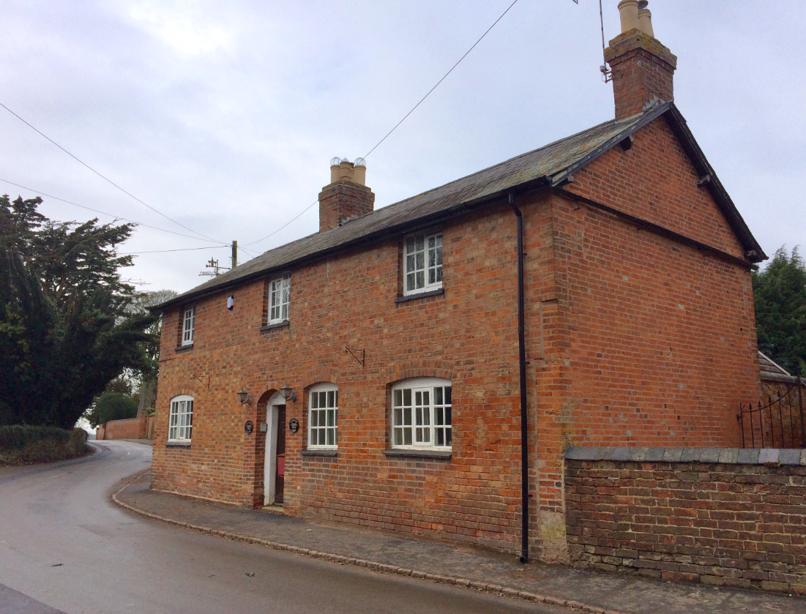

Building/Structure | (8) White Oaks, Smeeton Road, Saddington
Age | 1970s
Rarity  (as judged against local characteristics) | Not considered to be relevant.
Aesthetic value/ Architectural Interest | Not considered to be relevant.
Group value  (visual / design/ historic) | Not considered to be relevant.
Evidential value (significant contemporary or historic written record) | Not considered to be relevant.
Historic association  (Incl. important local figures) | Raymond Grant’s book: ‘History of Saddington’ (1999) – records that White Oaks (previously known as Mamtor) was the home of Peter Shilton, MBE (1986) and OBE (1991), between 1970 and 1975, goalkeeper for Leicester City Football Club between 1965 and 1975 and goalkeeper for England during the 1970s-90s.  Peter Shilton was England’s most capped football (goalkeeper) player and goalkeeper. His playing career overall was from 1963 to 1997.
Archaeological interest | Not considered to be relevant.
Designed landscapes | Not considered to be relevant.
Landmark status (strong communal / historical associations / especially striking aesthetic value) | Not considered to be relevant.
Social and communal value (source of local identity, distinctiveness, social interaction and coherence) | Remembered locally as the previous home of the famous Leicester City Football Club goalkeeper.
White Oaks  (Feb 2018) | 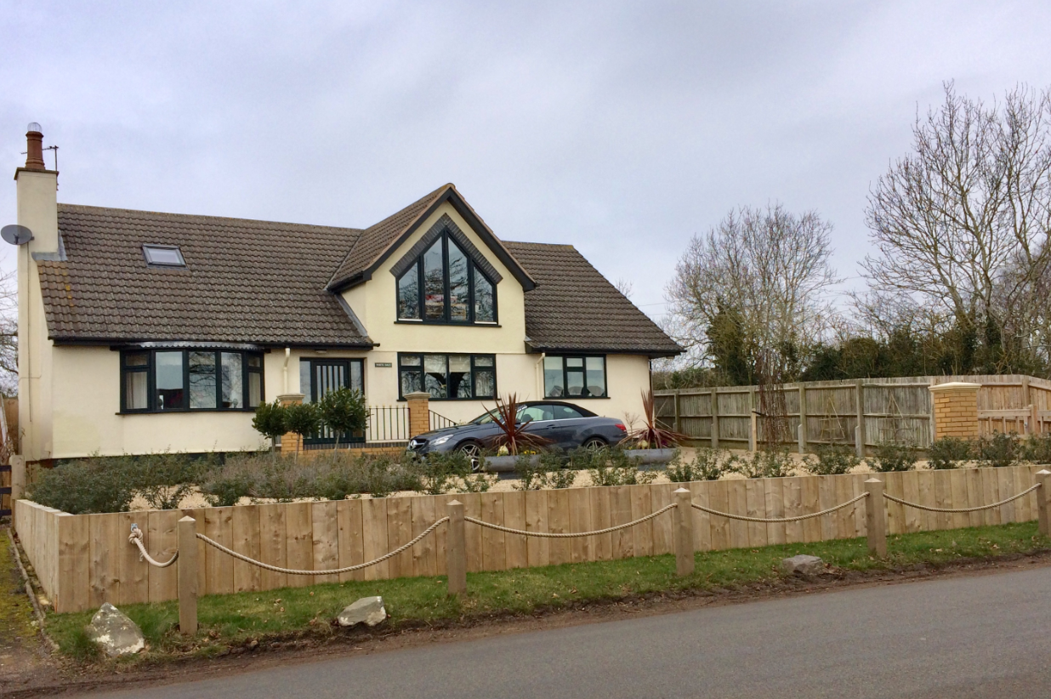

Building/Structure | (9) Village well, Weir Road, Saddington
Age | Original age is unknown, but shown as ‘pump’ on 1903 Ordnance Survey map.
Rarity  (as judged against local characteristics) | This example of a previously used village well is located on the newly created Village Green and is the only well in Saddington that in public view.
Aesthetic value/ Architectural Interest | The village well used to feed a drinking trough located on Weir Road. The head of the well was fitted with a steel man-hole cover in the early 20th century, so currently lacks much aesthetic appeal. The remains of the lead outlet pipe can be seen in the brickwork of the wall along Weir Road.  The well is fully brick lined from ground level down. The lead suction pipe can be seen down the well shaft as it rises out of the water and bends towards Weir Road where it would have connected to the pump.  The water level was measured in October 2017 as being 7.5m below the man-hole cover.
Group value  (visual / design/ historic) | The well is not associated with any other feature.
Evidential value (significant contemporary or historic written record) | Not available.
Historic association  (Incl. important local figures) | Not available.
Archaeological interest | Not considered to be relevant.
Designed landscapes | Not considered to be relevant.
Landmark status (strong communal / historical associations / especially striking aesthetic value) | The village well is a reminder of the days before running water was available in the village.
Social and communal value (source of local identity, distinctiveness, social interaction and coherence) | The village well is considered to be an interesting artefact dating back over a century. It is a historical feature on the new Village Green.
Village Well  (Feb 2018) | 